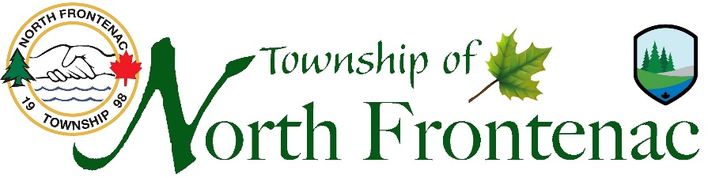
Emergency Preparedness Week - May 2 – 8, 2021
Are you prepared for a disaster?
Answer 10 questions to test your preparedness.
Emergency-Preparedness Quiz
WIN A 72-HOUR EMERGENCY KIT
Emergencies such as earthquakes, floods, tornadoes, wild fires and other hazards can strike at any moment leaving us without life sustaining essentials such as drinking water, food, light, heat and shelter. It's critically important to be prepared before such events occur. The Canadian government recommends having an emergency kit on hand with enough supplies to last at least 72 hours.
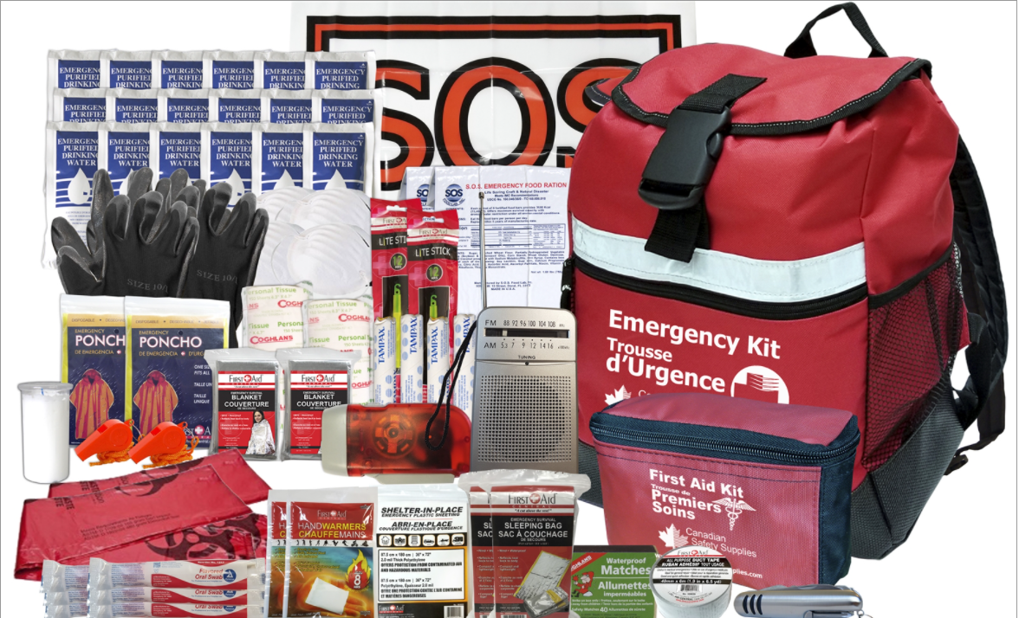
The quiz prize give-away will be launched on May 3, 2021 and run until May 8, 2021 and all submissions will be entered into a draw to win a 2 Person 72 Hour Emergency Survival Kit with Water. Draw to be held on May 10, 2021 and winner will be contacted.

